TO: Golf Coaches of Winning Team and Medalist
FROM: Wayne Ryan, CAA, Assistant Executive Director
DATE: September 28, 2020
SUBJECT: State Tournament Information

Congratulations to you and your team or individual for qualifying for the 2020 State Golf Tournament. Should you have any questions, please do not hesitate to call our office at 304-485-5494. Please review the following information.
1. Please review and keep for your records the letter, map and other information from the State Tournament Committee. (Attached)
2. Please refer to the August 2020 Interscholastic for other information concerning the State Tournament. (online) Please check for approved hotels online also.
3. Zides will be selling apparel during the State Tournament.
4. Action Images Photography will be taking still pictures of the tournament and will be selling them online https://www.actionimages.us/
5. Each golfer should have their own hand sanitizer, face covering water and towel.
Removing the flagstick is an individual option and a towel is recommended when doing so.

6. This year a head coach and one assistant coach may provide instruction. Coaches may coach their
players everywhere but greens and bunkers.

7. There will be no scoreboard this year. All scores will be posted at:

https://www.golfgenius.com/pages/2662413

Jones Course - Oglebay Park October 6th & 7th, 2020
Dear Coach,

Congratulations. Your team or medalist has qualified for the WVSSAC High School Golf Tournament. This letter has information that is essential for a successful tournament experience. The tournament is scheduled for October 6 & 7, 2020 at the Speidel Golf Club (Jones Course) at Oglebay Park in Wheeling, WV. This year there will be no scoreboard and all scoring will be posted at https://www.golfgenius.com/pages/2662413
The tournament banquet will not be held this year. On Monday, October 5th at 4:00 PM there will be a mandatory coaches’ meeting at the Haller Shelter by the Crispin Golf Course below the pool in Oglebay Park. It is very important that all coaches be in attendance as Scott Davidson (State Clinician) will discuss the code of conduct, rules, and assignments. Tournament packets will be distributed at this time.

Each golfer should have their own hand sanitizer, water and towel. Removing the flagstick is an individual option and a towel is recommended when doing so. Lunch and drinks will be provided at the turn for players and coaches on both days of the tournament. Range balls will also be provided for players prior to their tee time on both days. Pictures of the winning teams and medalists will be taken upon completion of the event and mailed to those respective schools.

A block of rooms and some cabins are reserved at Wilson Lodge (in Oglebay) for teams and families at a discounted rate. Reservations for these rooms must be made by the Wednesday immediately following completion of your respective regional championships. After that date, these rooms will no longer be blocked for the tournament and other lodging arrangements will have to be made. These rooms will fill up fast, so make your reservations early by calling 1-877-684-8078. Inform the reservations clerk that you are coming for the state tournament and are to receive the discounted rate. The booking number is 40895. The Wilson Lodge is located approximately two minutes from the course.
SCHOOLS MUST PROVIDE THEIR TAX-EXEMPT INFORMATION
Rooms $115 Deluxe Rooms $115.00 West Wing $189.00 Lakeside $199.00
Cabins (4 bedroom) $350.00 Estate House (6 bedroom) $700.00
A practice round is available on Monday, October 5. Tee times for Monday may be reserved based on regional participation. The following times are allocated for 2020.
Region I (all 3 classes) 8:30 am – 9:51 am
Region II, III & IV (all 3 classes) 12:06 am – 2:39 am
ONLY 4 players may play a hole together. If a team has more than 4 players, they would like to play in the practice round, the coach will need to manage that by rotating players in and out on a hole by hole basis. Teams not adhering to this rule will be asked to forfeit their practice round and be removed from the course with no refund.
Tee times and cart rentals for Monday’s practice should be made by calling 304-243-4050
On Monday, green fees are $20.00, range balls are $6.00 and carts at $31.00. Range balls are provided on Tuesday and Wednesday. During your practice round on Monday, coaches may reserve one golf cart per school for Tuesday and Wednesday at the Pro Shop. The cost is exactly $31.00 per day with your school tax form. If you are not practicing on Monday, you must still call the Pro Shop on Monday, NOT BEFORE, to reserve a cart for Tuesday and Wednesday.
The practice round is for players only. No coaches or parents will be permitted to play during this time. Parents and coaches may reserve tee times after 1:04 pm.
Play will begin on Tuesday and Wednesday at 8:30 AM. A pro start will be used on both days. The driving range will open at 7:00 AM. All coaches are to provide an adult spotter. Without this adult spotter, you may lose your privilege to coach. Spotters will be assigned ½ day coverage assignments.
A limited number of carts for spectators will be available. These carts will be restricted to cart paths only and must remain one-half hole away from the players. A cart instruction sheet is included in this packet.
For more information on Oglebay, visit www.oglebay-resort.com. We are looking forward to hosting this important event and we wish all golfers only the best of bounces.

Sincerely,
The West Virginia State High School Golf Committee

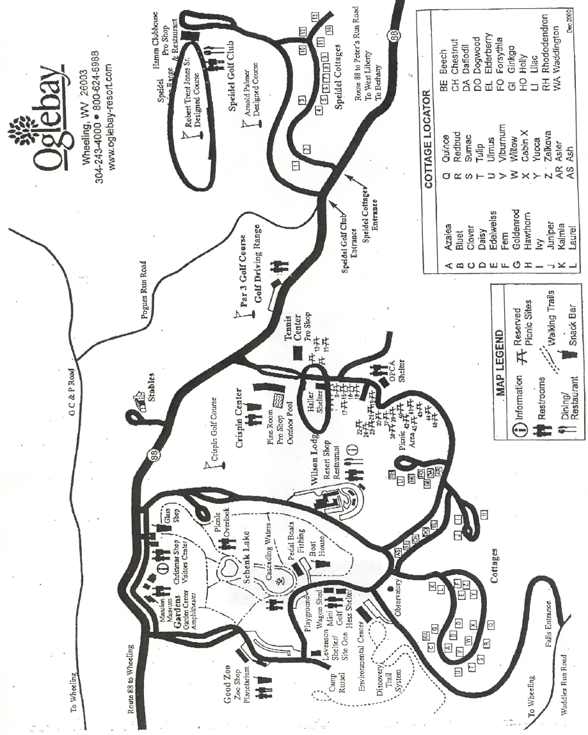

2020 West Virginia State High School Golf Championship
October 6th & 7th at Speidel Golf Club

Local Rules and Conditions of Competition

The Rules of the USGA and conditions govern play. See applicable competition’s “Notice to competitors” for additional local rules. DISREGARD ALL LOCAL RULES ON CLUB SCORECARDS. Appendix I refers to the Appendix of Local Rules in the current Rules of Golf.
Out of Bounds (Rule 27) – Defined by the inside points at ground level, of white stakes, lines or fence posts.

Water Hazards & Lateral Water Hazards (Rule 26) – Water Hazards are defined by yellow stakes or lines. Lateral Water Hazards are defined by red stakes or lines. When both stakes and lines are present, the stakes identify the hazard, and the lines define the margin of the hazard. Stakes or lines which are defining the margin of a hazard are in the hazard. Hazard stakes are moveable obstructions.

Practice (7-2 Note 2) No practice will be allowed on or near the putting green of the hole last played.

Ground Under Repair (Rule 25) – Defined by enclosed white lines. French drains (which are exposed trenches filled with rocks or stones) are ground under repair. Flowerbeds are ground under repair from which play is prohibited.

Embedded Ball – Through the Green, a ball which is embedded in its own pitch mark in the ground, other than sand, may be lifted without penalty, cleaned and dropped as near as possible to where it lay but not nearer the hole.

Immovable Obstruction (Rule 24-2)
A. All service roads and cart paths, unless otherwise noted by the Committee.
B. White lined areas tied into artificially surfaced roads, paths or obstruction and are not ground under repair.
C. Protection of young trees identified by stakes and support wires – Local Rule as prescribed in Appendix I Part B, Section 2 (page 93) shall be in effect.

Integral Parts of the Course – Include cables, rods, wires, or wrapping when closely attached to trees, lines in bunkers and artificial wall and pilings when located in hazards, unless otherwise noted by the Committee. No Relief

Permanent Elevated Power Lines or Cables – If a ball strikes a permanent elevated power line or cable, the stroke shall be canceled and replayed, without penalty (See Rule 20-5). If the ball is not immediately recovered, another ball may be substituted.

Doubt as to Procedure (Rule 3-3) In stroke play, if a competitor is doubtful of his rights or the correct procedure during the play of a hole he may, without penalty complete the hole with two balls.

After the doubtful situation has arisen and before taking further action, the competitor must announce to his marker or a fellow-competitor that he intends to play two balls and which ball he wished to count if the Rules permit. If he fails to do so, the provision of Rule 3-3b(ii) apply.

The competitor must report the facts of the situation to the Committee before returning his score card. If he fails to do so, he is disqualified.

Distance Measuring Devices - See Local Rule, Appendix 1, page 136 of 2012-2015 Rules of Golf.

Disqualification Penalty; Committee Discretion - See Rule 33-7 and Decision 33-7/8 in the 2012-2015 Decisions on the Rules of Golf. “Serious Breach of Etiquette” shall include but is not limited to: willful acts which damage to property or equipment on the course, use of abusive language, profanity, obscenities, throwing in anger of any golf equipment, displaying bad behavior, extreme rudeness, ridicule or intimidation toward fellow golfers, rules officials, spotters and unofficial markers.

Drop Zones on Holes 1, 4, 5, 8, 11, 13, 14, 15 have an optional drop zone.

Conditions of Competition

Tee Markers: Men shall play Blue Markers and Ladies shall play White Markers.

Golf Balls: Only brands of balls tested and approved by the USGA.

Time of Starting: Tuesday & Wednesday will be a pro start beginning at 8:30 AM.

Discontinuance of Play: One long blast of horn (players are not allowed to finish hole). Practice areas shall be closed during suspension of dangerous situation until the Committee declares them open. A player using such practice areas will be subject to a penalty of disqualification.

Resume Play: Two short blasts of horn.

Transportation: Players must not ride in any form of transportation during the stipulated round unless authorized by the committee.
Player’s bags may be transported to and from starting holes. A designated shuttle may transport players to and from their starting holes.

Deciding Ties: In the event of a tie for first and second place, the fourth golfers score on each team will be added to the team total score as the first tie breaker. If the first tie breaker does not break the tie, all teams tied for first and second place for each class in the State Tournament will play a “sudden death” best ball team play or team score which will consist of four players for each team, scoring three best, to determine first and second place.

Close of Competition: The competition shall be deemed to have closed when all scores have been approved and posted on the official scoreboard.

Awards: A plaque will be awarded to the First place & Second place teams in each class. In addition, awards will go to individual medalist and the 8, plus ties, all tournament team.

Conduct: Unsportsmanlike conduct shall include but not be limited to: club throwing, willful acts which damage property or equipment on the course, use of abusive language, profanity, obscenities, and other unsportsmanlike conduct as determined by the Golf Rules Committee. Penalties imposed will be disqualification. Zero Tolerance

Use of Tobacco Products: Smoking or the use of tobacco products by coaches or players on the course or near the clubhouse is not permitted. Violation will result in disqualification.

Spectators: Spectators are NOT PERMITTED to converse with participants. It will be the responsibility of contestants in each foursome to caution ANY spectator from talking to or interfering with contestants in their group. Failure to do so may result in a penalty of disqualification of contestants involved. Spectators and Spectator Carts Must Stay on Cart Paths We suggest spectators stay one shot ahead of the group because spectators may also act as spotters for the group.

The head coach may coach the entire course except for putting greens and sand bunkers.

Cell Phones: Use of cell phone (phone ringing is considered as use) on the course by players and coaches is PROHIBITED. Any spectator use is to be in an area of the course that does not interfere with play. All use of cell phones by players and coaches shall be limited to the parking lot and clubhouse areas. Penalty for first offense is two strokes. Penalty for second offense is disqualification.

WEST VIRGINIA PGA

Golf Rules Committee: Charles Fields, Scott Davidson, Bill Robertson, Shane Rice

West Virginia State High School
Golf Championship
Driving Range Procedures

Sponsored By The
West Virginia
Golf Course Superintendents

Attention players and coaches. Tuesday & Wednesday we will have a pro start beginning at 8:30 AM. Therefore, in our attempts to have equality among all players, we will be distributing one large bucket of balls per team and one small bucket per medalist. The coach or designated player may pick them up at the range beginning at 7:00 AM each day.

West Virginia State High School
Golf Championship

Spectator Information

Spectators are not permitted to converse with participants. It will be the responsibility of contestants in each foursome to caution ANY spectators from talking to or interfering with contestants in their group. Failure to do so may result in a penalty of disqualification of contestants involved. Spectators and spectator carts must stay on cart paths. We suggest spectators stay one shot ahead of the group because spectators may also act as spotters for the group. Use of cell phones on the course by players is prohibited. Coaches or spectators must silence their cell phones.
West Virginia State High School
Golf Championship
Mandatory Coaches’ Meeting

There will no banquet this year.
There will be a mandatory coaches’ meeting on Monday, October 5th at 4:00 PM at the Haller Shelter by the Crispin Golf Course below the pool in Oglebay Park.

It is very important that all coaches be in attendance as Scott Davidson (State Clinician) will discuss the code of conduct, rules, and assignments.

Tournament packets will be distributed at this time.

West Virginia State High School
Golf Championship
Cart Rental Information

Carts may not be reserved.
They are available 1st come, 1stserve only.
The price will be $35.00 which includes tax.

Carts will be available Tuesday & Wednesday for the WV State Golf Tournament. We only have limited carts available. Carts will not be available until 8:30 am each morning. Beginning at 7:00 am each morning you may rent your cart at the designated area. At 8:30 you may go to the cart area behind the bag drop with your slip and pick up your cart. Carts should be returned to the same area at end of play.

SCOREBOARD INFORMATION

This year there will be no scoreboard.

All scoring will be posted at online at

https://www.golfgenius.com/pages/2662413

